BIT 4107 - Mobile Application Development
STUDENT LOGBOOK
Week 9 - Device Features: GPS & Camera
Project: SpareDash - Kenyan Automotive Spare Parts Platform
Student Name | Newton kariithi
Admission Number | BIT/2025/31318
School/Faculty | School of Computing and Informatics
Programme | Bachelor of Information Technology (BIT)
Academic Year | 2025/2026
Semester | Semester 2
Unit Code | BIT 4107
Unit Name | Mobile Application Development
Lecturer | NYORO MICHAEL

Week 9: Device Features Integration - GPS & Camera

Topic | GPS Location Services & Camera Integration in Flutter
Date | Week 9 - July 2026
Project | SpareDash - Parts Near Me (GPS) & Profile Photo (Camera)
Screenshots Attached | Yes
Packages Added | geolocator: ^13.0.2, image_picker: ^1.1.2

Learning Objectives
- Integrate GPS location services into a Flutter app using the geolocator package
- Request and handle runtime permissions for LOCATION and CAMERA on Android
- Display live GPS coordinates (latitude, longitude, accuracy) on screen
- Calculate distance between user location and seller estates using Geolocator.distanceBetween()
- Capture photos using the device camera and display them in the app using image_picker
- Build a 'Parts Near Me' screen that matches user location to nearest Nairobi sellers
- Handle GPS edge cases: service disabled, permission denied, permission permanently denied

Practical Activities Undertaken
# | Activity | Outcome | Screenshot Label
1 | Added geolocator: ^13.0.2 to pubspec.yaml and ran flutter pub get | geolocator 13.0.4 and 5 companion packages installed; FlutterGeolocator attached to activity on first run | Fig 9.1 - pubspec.yaml with geolocator
2 | Added ACCESS_FINE_LOCATION, ACCESS_COARSE_LOCATION, ACCESS_BACKGROUND_LOCATION to AndroidManifest.xml | Permission dialog now appears on first GPS request on INFINIX X669 | Fig 9.2 - AndroidManifest.xml with location permissions
3 | Created PartsNearMeScreen with GPS coordinates display and Get My Location button | Screen shows latitude, longitude, accuracy and nearest seller estate with distance | Fig 9.3 - Parts Near Me screen with GPS coordinates
4 | Implemented runtime permission handling with Geolocator.checkPermission() and requestPermission() | App shows specific error messages for: service disabled, permission denied, permission permanently denied | Fig 9.4 - Location permission dialog on phone
5 | Built estate proximity detection using Geolocator.distanceBetween() with 10 Nairobi estate coordinates | App correctly identifies nearest seller estate and shows distance in meters/km | Fig 9.5 - Nearest estate detected with distance
6 | Filtered SQLite parts by nearest estate location and displayed in list | Parts list updates dynamically showing items from the nearest Nairobi seller location | Fig 9.6 - Parts list filtered by nearest location
7 | Added image_picker: ^1.1.2 to pubspec.yaml and CAMERA permission to AndroidManifest.xml | image_picker 1.2.3 installed; CAMERA permission added to manifest | Fig 9.7 - pubspec.yaml with image_picker
8 | Created CameraScreen with Capture Photo and Choose from Gallery buttons | Camera opens on INFINIX X669; captured photo displays in circular avatar; Retake and Save options work | Fig 9.8 - Camera screen with captured photo
9 | Added My Photo quick action button to home screen alongside Near Me, My Orders, Profile | 4 quick action buttons visible on home screen; My Photo navigates to CameraScreen | Fig 9.9 - Home screen with 4 quick action buttons
10 | Added Parts Near Me green banner below Vehicle Search banner on home screen | Green gradient banner with GPS icon navigates to PartsNearMeScreen | Fig 9.10 - Parts Near Me banner on home screen

GPS Implementation Details
Package | geolocator 13.0.4
Permission (Android) | ACCESS_FINE_LOCATION + ACCESS_COARSE_LOCATION + ACCESS_BACKGROUND_LOCATION
Location Accuracy | LocationAccuracy.high with 15 second timeout
Coordinates Displayed | Latitude (6 decimal places), Longitude (6 decimal places), Accuracy (meters)
Distance Calculation | Geolocator.distanceBetween(userLat, userLng, estateLat, estateLng) — returns meters
Estates Mapped | 10 Nairobi estates: Kirinyaga Road, Grogan Road, Industrial Area, Thika Road, Ngong Road, River Road, Westlands, South B, Mombasa Road, Lunga Lunga Road
Error Handling | 3 specific error states: location service disabled, permission denied, permission permanently denied

Camera Implementation Details
Package | image_picker 1.2.3
Permission (Android) | CAMERA + READ_EXTERNAL_STORAGE + WRITE_EXTERNAL_STORAGE
Camera Source | ImageSource.camera (front camera default) and ImageSource.gallery
Image Quality | 80% compression for optimal file size vs quality balance
Display | Circular ClipOval avatar — 200x200px with blue border
Actions | Capture Photo, Choose from Gallery, Retake Photo, Save
Error Handling | Try-catch with user-friendly message if camera permission denied

Screenshots / Evidence

[SCREENSHOT: Fig 9.3 - Parts Near Me screen with GPS coordinates]
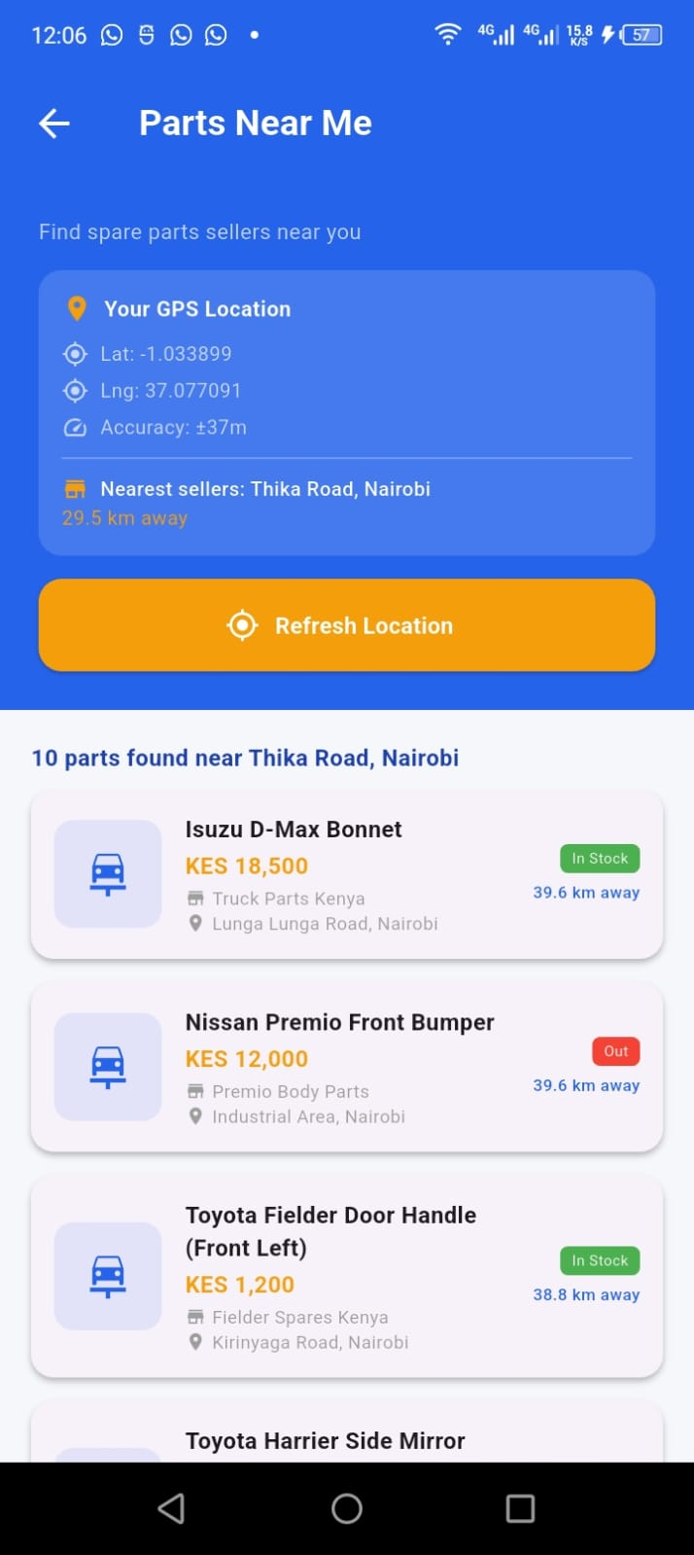

[SCREENSHOT: Fig 9.4 - Location permission dialog]
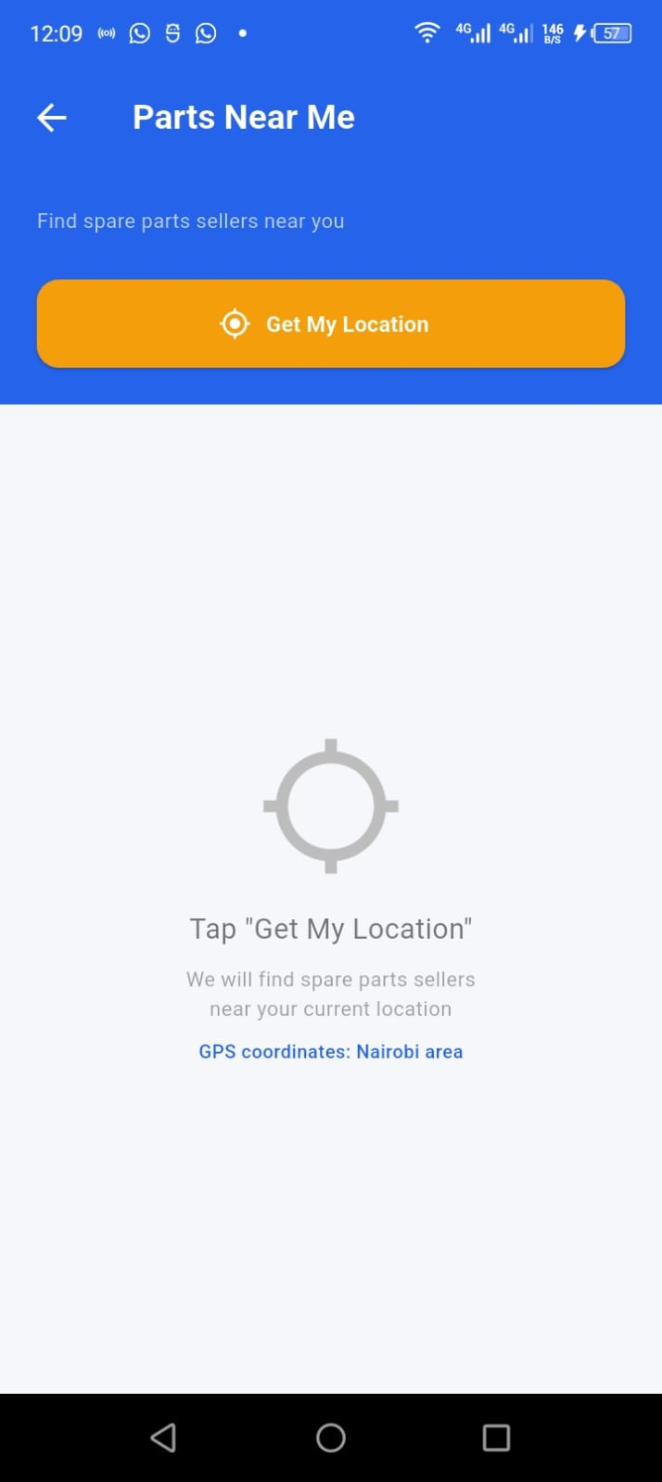

[SCREENSHOT: Fig 9.5 - Nearest estate with distance]
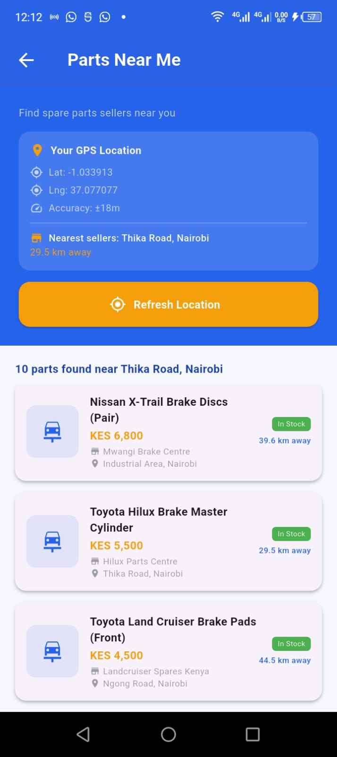

[SCREENSHOT: Fig 9.8 - Camera screen with captured photo]
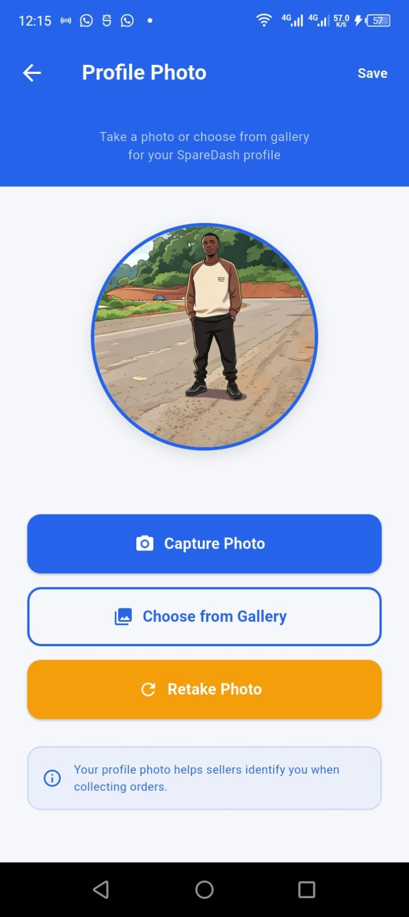

[SCREENSHOT: Fig 9.9 - Home screen 4 quick actions]
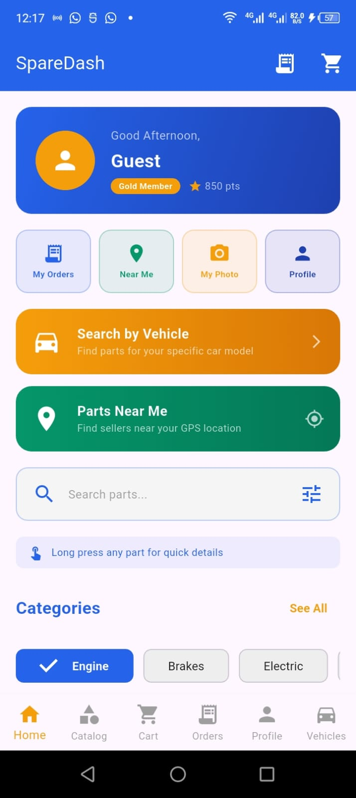

[SCREENSHOT: Fig 9.10 - Parts Near Me banner]


Tools / Software Used
IDE | Android Studio Narwhal (2025.3.4)
Flutter SDK | Flutter 3.44.2
Dart SDK | Dart 3.12.2
Test Device | INFINIX X669 (Android, USB debugging enabled)
GPS Package | geolocator 13.0.4 with geolocator android 4.6.2
Camera Package | image picker 1.2.3 with image_picker_android 0.8.13
New Screens | PartsNearMeScreen, Camera Screen
Permissions Added | ACCESS_FINE_LOCATION, ACCESS_COARSE_LOCATION, ACCESS_BACKGROUND_LOCATION, CAMERA, READ/WRITE_EXTERNAL_STORAGE

Challenges & Solutions
Challenge | Solution
Location permission dialog never appeared | ACCESS_FINE_LOCATION permission was missing from AndroidManifest.xml — added all 3 location permissions using PowerShell Set-Content command
GPS taking too long to get location | Set LocationAccuracy.high with 15 second timeLimit — first GPS fix always slower on cold start; subsequent calls are faster
Parts Near Me showing all parts not filtered | Used location string matching — extracted estate key from nearest estate name and filtered SQLite parts by location field containing that keyword
Camera screen not accessible from home | simple_home.dart quick actions row needed camera_screen.dart import and new My Photo button — updated to 4-button row

Personal Reflection
Week 9 made SpareDash genuinely location-aware — a user in Westlands now sees different parts than one in Industrial Area, exactly as the Kenyan market works. The GPS feature closes the gap between the app and real on-the-ground spare parts hunting that Nairobi mechanics do daily. Camera integration personalizes the experience, making SpareDash feel like a complete product.

